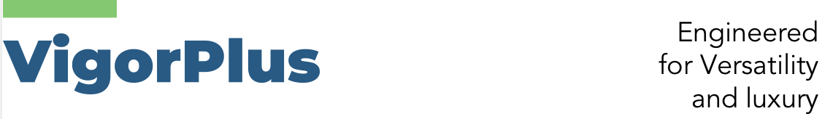
Regional Agency Application Form

Many thanks for your interest in Vigor Plus Company. Our company is very willing to develop a local Faux leather and Coated fabrics market with you, hoping to establish a "win-win" cooperative relationship after mutual understanding. Please fill in the following content truthfully and in detail after browsing the basic information of the website, our evaluation team will arrange the sales manager to contact you, thank you!

General Information
Applicant | Individual □Company
Name |  | Legal representative
Registered address

Registered Date |  | Registered capital
Company Size | Total number of existing employees:  Includes Sales Person , Customer service Person , Others .
Company business situation

Business scope
Main business
Main customer type | Importers Wholesalers □Retailers □Projects □Manufacturers Others
Current sales area
Turnover of the previous year
Warehouse Facility | □No □Yes SQM
Applications

Country to Apply
Target turnover
Time of proposed project | 1month □ 3 month □ 6 month  others ：
What is your Survey and Expectations to the local market
What is your advantages in the market and clients
What is your plan on business development
What is your plan to invest in manpower, material and other resources
What is your recommendations and requirements in cooperate with our company

Thanks again for taking you time to complete this form, we will keep all your information confidential. Please fill in it carefully and in detail so that our company can review your agency qualifications. Please email the completed application form to info@vigorplustex.com , we will contact with you as soon as possible after reading the above information, thank you!

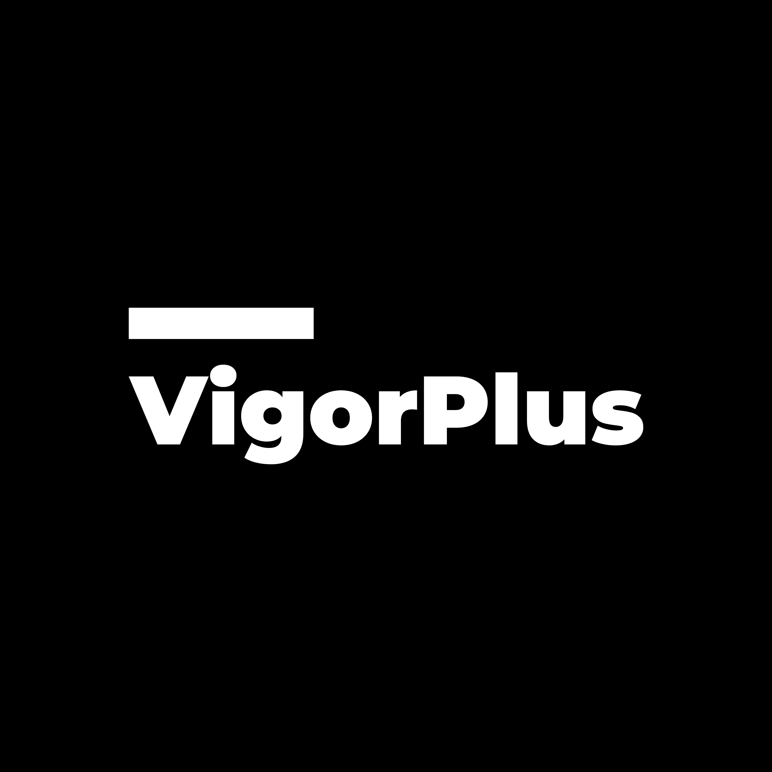
www.vigorplustex.com

